**Q1 : What do you mean by AutoComplete feature in Excel and what are the benefits of using this feature?**

Ans : What is AutoFill? Excel has a feature that helps you automatically enter data. If you are entering a predictable series (e.g. 1, 2, 3…; days of the week; hours of the day) you can use the AutoFill command to automatically extend the sequence.

**Q2 : Explain working with workbooks and working with cells.**

Ans : An Excel file, often referred to as a workbook, contains one or more spreadsheets, or worksheets. Each box in the worksheet area is referred to as a cell. Each cell has a cell address, which is composed of a column reference and a row reference. The letters across the top of the worksheet make up the column reference.

**Q3 : What is fill handle in Excel and why do we use it?**

Ans : You can quickly copy formulas into adjacent cells by using the fill handle. When you drag the handle to other cells, Excel will show different results for each cell. Fill Handle is a feature in Excel that enables you to auto-complete a list in a row/column by simply dragging it using your mouse. A basic understanding of fill handle in Excel could save you some time and make you more productive.

**Q4 : Give some examples of using the fill handle.**

Ans :'Fill Handle' is a tool that you can use to autocomplete lists in Excel. For example, if you have to enter numbers 1 to 20 in cell A1:A20, instead of manually entering each number, you can simply enter the first two numbers and use the fill handle to do the rest.

**Q5 : Describe flash fill and what the different ways to access the flash fill are.**

Ans : Flash Fill automatically fills your data when it senses a pattern. For example, you can use Flash Fill to separate first and last names from a single column, or combine first and last names from two different columns. Note: Flash Fill is only available in Excel 2013 and later.

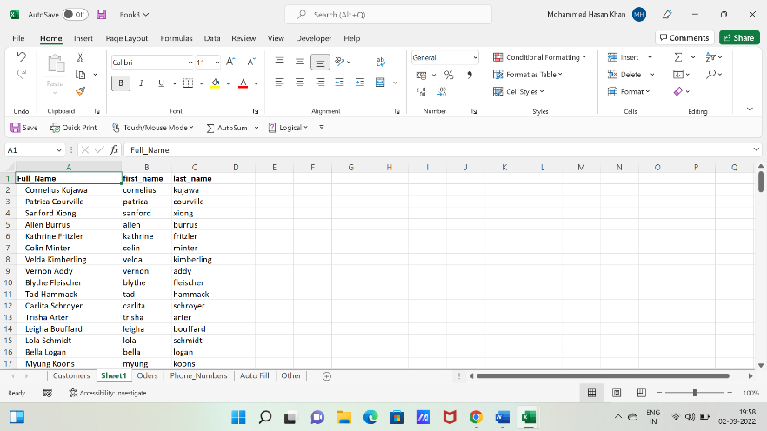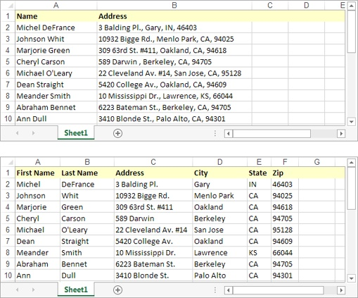**Q6 : 6. Extract first name and last name from the mail id and then from the address column, extract the city, state, and pin code using the flash fill. Given below is an example of the columns you have to create. Paste the screenshot of what you have created using the flash fill command.**